Brunswick Volunteer Ambulance & Rescue Inc.

Will be having Seafood Meals or Sandwiches “to go” or “eat in” at 200 West Potomac St. on Saturday March 23rd from 3pm–7pm or until sold out.

Due to the increase of Seafood price we had to the raise prices

4 oz. Homemade Crabcake Sandwich-$15.00,
Platter-$20.00

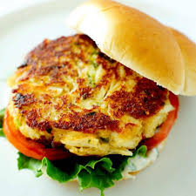
21/25 ct.–½lb Steam Shrimp-$20.00, 1/2lb Shrimp Platter-$25.00, 1lb Shrimp only- $30.00

Fried Fish Sandwich-$ 9.00, 2pc Platter $14.00

Homemade Crab Soup-$10.00 pt., $17.00 qt

Oyster Sandwich-$14.00, Platter-$20.00

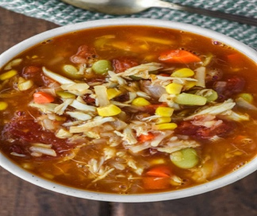
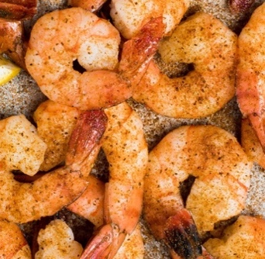
Platters include either Macaroni Salad, Applesauce & Baked Beans or Fresh Cut Fries, Applesauce & Baked Beans. Sandwiches include Lettuce & Tomato

For more information contact
Michele Dilling @ 240-409-4114
THANK YOU FOR YOUR SUPPORT

